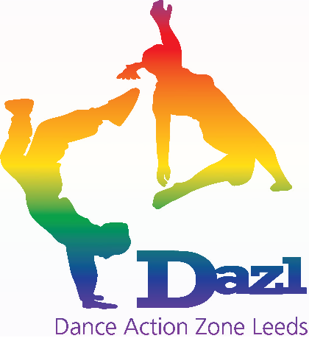
DAZL Code of Conduct

This Code of Conduct is the result of consultation with DAZL Tutors and is designed to support what staff expressed as shared expectations of how anyone working in a DAZL dance session should conduct themselves. This is a working document so tell us if you feel anything is missing!

Professional Behaviour
- All teachers / assistants must arrive 10 minutes before the session is due to start
- Every participant is to be treated equally (see DAZL Equal Opportunity Policy)
- All DAZL staff are expected to give full energy, focus and commitment
- Absolutely no swearing at any time before, during or after a dance session
- Mobile phones must be switched off at all times during sessions (Compulsory)
- Only professional conversations related to the dance session should be discussed in front of the students – NO personal issues or inappropriate conversation should be conducted.
- Chewing gum is not permitted while dancing
- No smoking (In front of any DAZL participant)
- Absolutely no alcohol is to be consumed when supervising or assisting a group

Dress Code
- Wear suitable footwear e.g., trainers, jazz shoes or bare feet for dancing, also do not allow participants to dance in socks or other inappropriate footwear
- No overtly revealing clothing
- No large earrings or chains are permitted as they can be dangerous
- Staff must wear clothing suitable for dancing that allow free movement (track suit bottoms or dance clothes etc – no jeans (DAZL Top must be worn at all DAZL sessions)

Behaviour Management
- Bullying, verbal abuse, physical violence or intimidating behaviour is not tolerated
- DAZL believes that no young person is bad, only behaviour is bad. As such comments should be directed at the behaviour NOT the person e.g.,
NEVER: “you are bad”
ALWAYS: “that behaviour is unacceptable because….”
- Always focus on positive achievements not negatives
- NEVER seek to single out and/or humiliate a participant in front of others

Delivery
We expect our tutors/assistants and dance leaders at every session to have the following:-
- Be equipped, which includes iPod/Music Dock or sound system/jack leads and any appropriate music you require for the session (all radio edit/clean versions MUST be used)
- Consent forms have been completed for all students
- Registers/contact list/first aid kit
- Every half term you should ensure that all registers/consent & feedback forms (SCHOOL and STUDENT) are handed in at the office
- All groups taught should be learning towards a routine to perform at a DAZL show

If you need to arrange cover…
If you have agreed to teach a session you are expected to honour that agreement. We do understand however, that on rare occasions it might be necessary for you to arrange a cover tutor. In that instance you should do the following:

  - Inform the Director as soon as possible - always well before the session begins! Where cover is needed the Director must agree the cover for the session is appropriate. THE DIRECTOR MUST BE INFORMED OF ALL COVERED CLASSES IN ADVANCE.

  - If the Director is unavailable inform Amanda Noble, Finance and Administration Manager.

  - If both the Director and Finance and Administration Manager are unavailable then leave a message on either the DAZL phone number – if you do leave a message it is YOUR responsibility to ensure that your message has been received and the right people are informed.

  - The school must also be informed of the approved change, you must never cancel a session without speaking to the DAZL office first.

  - If you fail to turn up for a session or inform DAZL Office, we reserve the right to terminate your contracts and remove you from the programme.

I have read and understood the above code of conduct and I agree to abide by this code of conduct when working for Dance Action Zone Leeds

Print name …………………………………………………………

Signature …………………………………………………………

Date …………………………………………………………

